WAHA KUN System Overview

Core Idea
WAHA KUN is an AI-powered mobile application designed to improve water sustainability and irrigation management in oasis communities. The system helps farmers, technicians, experts, and supervisors report, diagnose, monitor, and resolve water-related issues through a centralized digital platform. It combines Artificial Intelligence (AI), image analysis, voice reporting, geographic mapping, and community collaboration to support efficient water resource management.

Problem Addressed
Oasis communities depend heavily on limited water resources. Current reporting methods are often manual and fragmented, causing:
- Delayed reporting of water problems.
- Slow maintenance response.
- Poor documentation and monitoring.
- Water waste due to leaks and irrigation failures.
- Difficulty in identifying recurring issues and planning sustainable solutions.

Proposed Solution
WAHA KUN provides a smart mobile platform where users can:
- Report water-related problems using images, voice recordings, and text.
- Allow AI to analyze the reported issue.
- Receive recommendations for corrective actions.
- Track the status of issue resolution.
- Collaborate with experts and community members.
- Monitor problems on an interactive map.

Main Users
- Farmers
- Irrigation Technicians
- Water Experts
- Supervisors
- Local Authorities

Main Use Cases

Farmer
- Login
- Verify Profile
- Report Water Problem
- Upload Image
- Record Voice
- View AI Diagnosis
- View Map
- Track Issue Status
- Add Comment

Technician
- View Assigned Issues
- Update Repair Status
- Add Repair Notes

Expert
- Review Diagnosis
- Provide Recommendation
- Verify Issue

Admin
- Manage Users
- Monitor Dashboard
- Generate Reports
- Manage Notifications

Main Features
Microservices Architecture

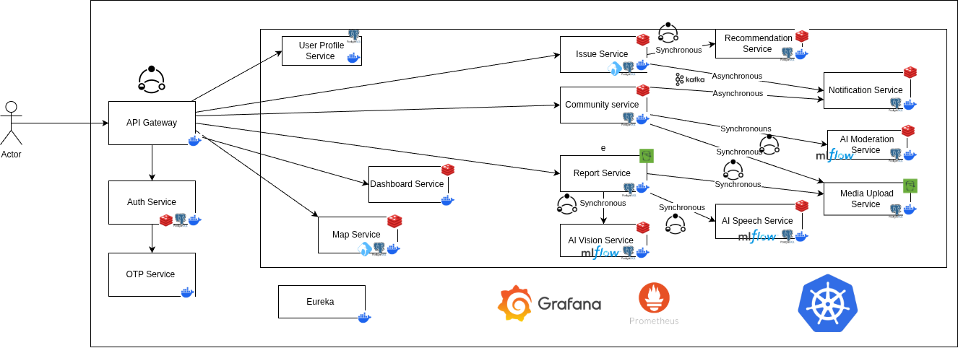

1.Auth Service
- Mobile OTP login
- JWT session management
- Role-based access:
  - Farmer
  - Technician
  - Supervisor
  - Expert
Purpose: Secure identity + controlled access
OTP services
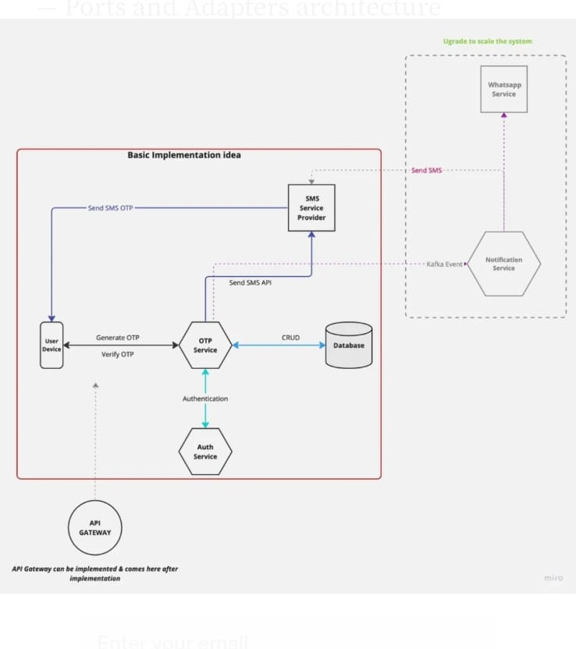

2.User Profile Service
- Name confirmation
- Region / village selection
- Role selection
- Secure profile data storage
- Profile update & retrieval
Purpose: Trusted user identity system

3.Report Service
- Upload:
  - Images
  - Voice
  - Text
- Stores media (S3)
- Sends data to AI pipeline
Purpose: Entry point for real-world issues

4.AI Vision Service
- Detects water issues from images:
  - Leaks
  - Canal damage
  - Blockage
  - Overflow
- Outputs:
  - Problem type
  - Confidence score
  - Severity level
SLA: < 3 seconds

5.AI Speech Service
- Arabic + dialect speech-to-text
- Converts voice → structured text
Purpose: Solve literacy + language barriers

6.Issue Service (Core Engine)
Tracks full lifecycle:
Reported → Diagnosed → Verified → Assigned → Scheduled → Repaired → Closed
Uses:
- PostGIS for geospatial tracking
This is the main workflow brain

7.Recommendation Engine
AI-based decision support:
- Repair suggestions
- Irrigation adjustments
- Priority ranking
- Escalation logic
Purpose: Smart decision-making layer

8.Community Service
- Threads & discussions
- Comments & replies
- AI moderation filters noise
- Expert engagement
Purpose: Social + collaborative problem solving

9.Map Service
- Displays issues geographically
- Clustering by:
  - Severity
  - Type
  - Status
Uses:
- PostGIS
- Leaflet / Google Maps
Purpose: Spatial intelligence layer

10.Notification Service
Real-time alerts:
- Diagnosis complete
- Critical leak detected
- Expert assigned
- Repair updates
Purpose: Real-time system responsiveness

11.Dashboard & Analytics Service
- Admin/supervisor monitoring panel:
- Number of reported issues
- Critical problem locations
- Resolution rates
- Water sustainability trends
- Maintenance workload
- Support large numbers of users
- Expansion to multiple oasis regions

System Workflow (End-to-End)
- Farmer reports issue (image/voice/text)
- Report Service stores data
- AI Vision + Speech analyze input
- Issue Service creates workflow case
- Recommendation Engine suggests actions
- Experts assigned via system
- Map Service visualizes issue
- Notifications update users
- Community supports discussion
- Issue closed after repair verificatio

